SD Case Study

Student Name: Addison Babcock User ID (###) 036

Date: November 1, 2016

|  |  |
| --- | --- |
| Description | Your Data |
| Search Term 1 (p4) | 036 |
| Customer Number (p6) | 0000025004 |
| Contact person (p8) | 0000000005 |
| Inquiry number (p14) | 10000003 |
| Quotation number (p19) | 20000002 |
| Standard order number (p22) | 6 |
| Outbound delivery number (p29) | 80000005 |
| Customer invoice number (p38) | 90000005 |
| Payment document number (p43) | 1400000004 |

Insert an image of your document flow from page 45 (Use Snipit tool). The image should only be of the data i.e., not a full screen shot. (Remove this image and replace it with your own.)

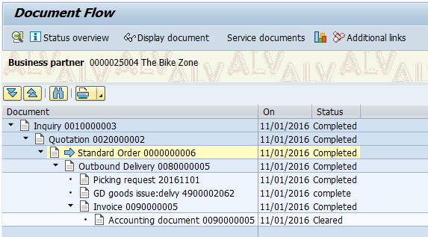

Insert an image of the invoice you created.

